VISUALIZATION STUDY REPORT
1. Objective
The main objective of this task is to analyze the Amazon product dataset using data visualization techniques and extract meaningful insights. The goal is to understand patterns in product categories, ratings, pricing, and relationships between different features.

2. Introduction
Data visualization is an important part of data analysis because it helps convert raw data into easy-to-understand graphical representations.
In this project, I worked on an Amazon product dataset and used Python libraries such as Pandas, Matplotlib, and Seaborn to explore and visualize data. The visual analysis helped in identifying trends, distributions, and relationships between different attributes.

3. Dataset Description
The dataset includes information about Amazon products such as:
- Product Name
- Category
- Rating
- Actual Price
- Discounted Price
Before visualization, the dataset was cleaned and prepared to ensure accurate results.

4. Tools & Technologies Used
- Python
- Pandas (for data handling)
- Matplotlib (for plotting graphs)
- Seaborn (for statistical visualization)
- Jupyter Notebook / Google Colab

5. Data Visualization & Observations

5.1 Top Product
The frequency of product categories was analyzed using value counts and visualized using bar charts.
Observation:
- A few categories dominate the dataset.
- Product distribution is not uniform across all categories.
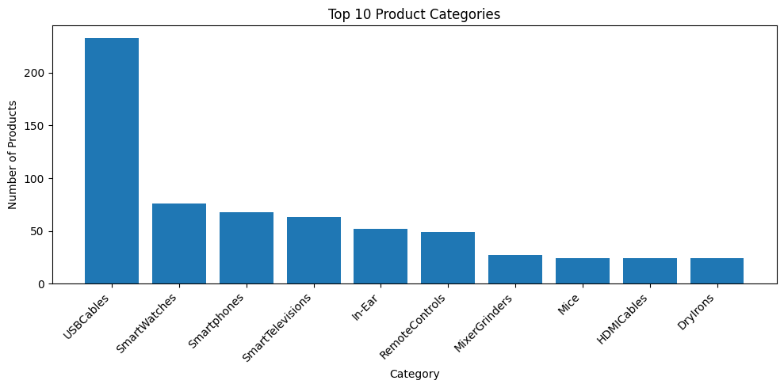
5.2 Rating Distribution
Ratings were converted into numeric values and visualized using a histogram.
Observation:
- Most products have ratings between medium to high values.
- Very few products have low ratings. 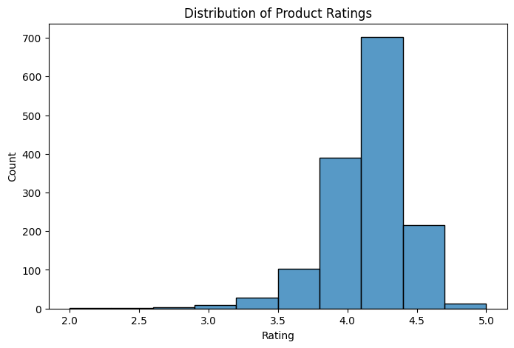

5.3 Actual Price vs Discounted Price
A scatter plot was used to compare original price and discounted price.
Observation:
- There is a strong relationship between actual and discounted prices.
- Discounts are widely used across products.
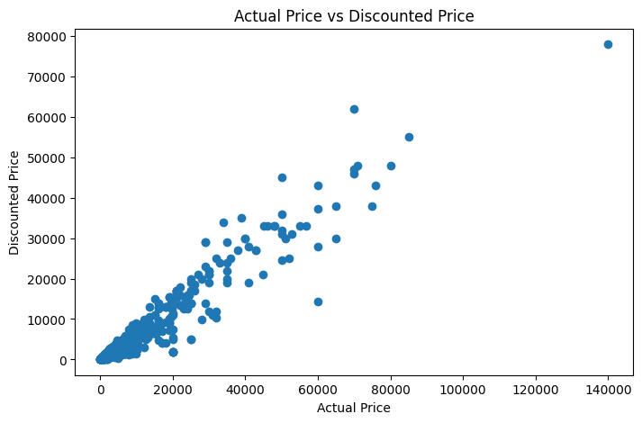
5.4 Rating Spread
A boxplot was used to understand the distribution of ratings.
Observation:
- Ratings are mostly concentrated in a narrow range.
- Few outliers are present.


5.5 Correlation Heatmap
A heatmap was created using numerical features.
Observation:
- Price-related variables show some correlation.
- Helps in understanding relationships between numerical data.
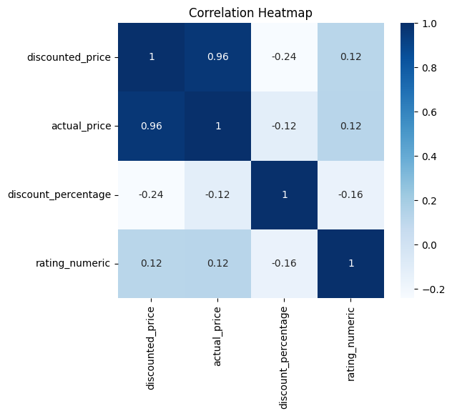
5.6 Top 10 Highest Rated Products
Products were sorted based on rating to identify top-performing products.
Observation:
- Only a few products achieve very high ratings.
- These products stand out clearly in the dataset.
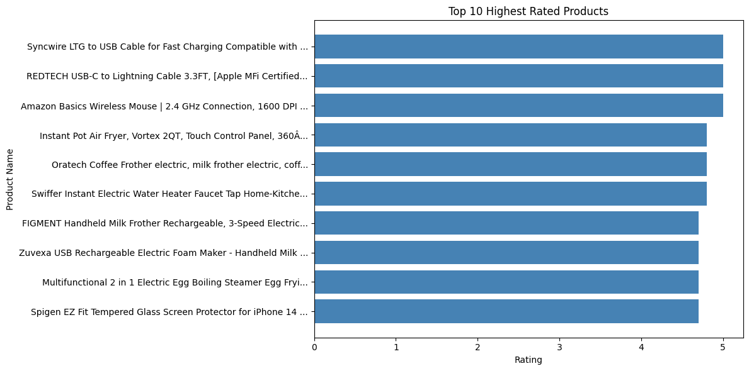
6. Key Findings
- Product categories are unevenly distributed.
- Most products have good ratings.
- Discounts significantly influence pricing strategy.
- Visualizations make it easy to identify trends and patterns.
- A small number of products dominate the high-rating segment.

7. Conclusion
This task helped in understanding how raw dataset information can be transformed into meaningful insights using visualization techniques. It improved my skills in data analysis, Python programming, and graphical representation of data.

8. Final Outcome
This project demonstrates:
- Data cleaning and preparation
- Exploratory Data Analysis (EDA)
- Multiple visualization techniques
- Insight extraction from real-world data

